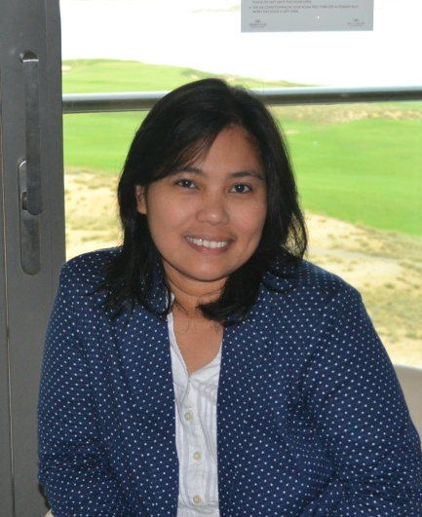

It is my great pleasure to be your New Teacher Assistant this year. My name is Mrs. Reyna P. Aguinaldo. I am happily married and I have to wonderful and lovely kids namely Princess Joshelle who is already 17 years old and Joshua is already 12 years old. I grew up and finished my studies in Metro Manila Philippines. I have lived here in Dubai for the past 13 years and I can call it as my second home. My experience in previous school as Learning Support Assistant has made me wholesome and rewarding as well as I have learned to deal with different character and nature. As I have given the chance to join GWA this year is a new open door for me to learn more and increase my knowledge and professional life. Me and my family loves to travel and we love watching movies together. Cooking our national dish is one of our past time also.

